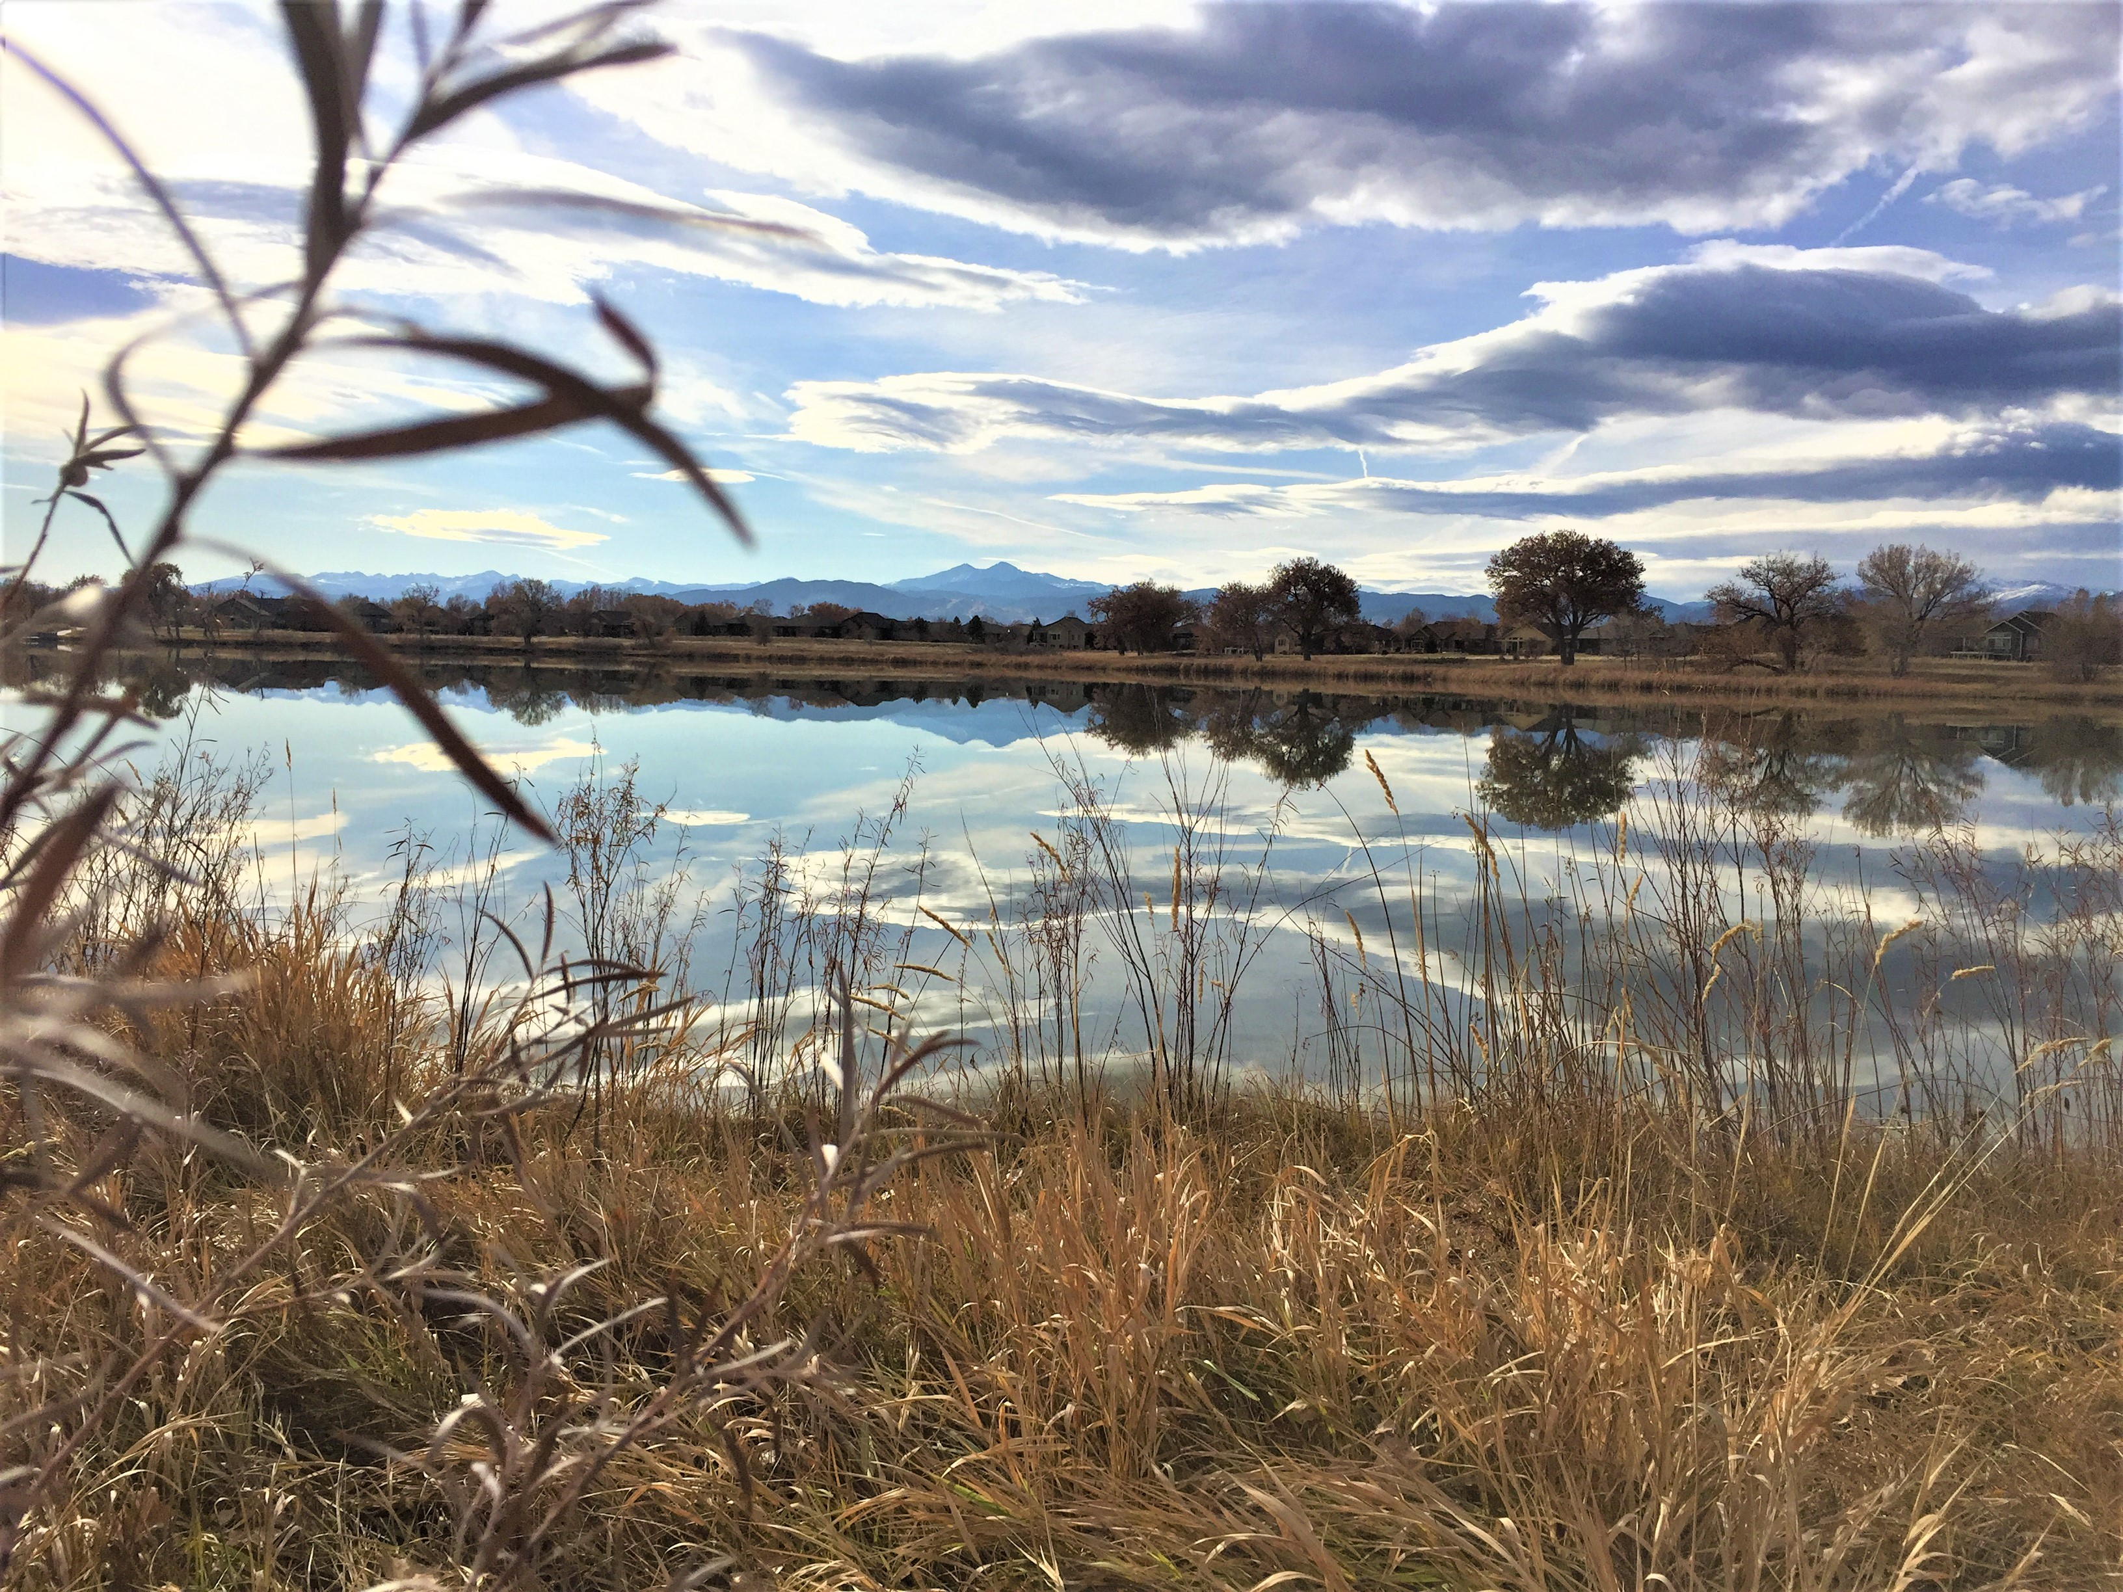

Forest Therapy ~ Shinrin Yoku

A Nature Immersion Experience

Forest Therapy is inspired by the Japanese practice of Shinrin-Yoku, which translates to "forest bathing". Since the 1980's scientists in Japan started experimenting with the effect spending time in an outdoor natural setting has on the physical body. They discovered and documented amazing health benefits from lowered blood pressure and pulse rate, to decreased levels of the stress hormone Cortisol, and an increase in the amount of Natural Killer cells in the body. Since that time Forest Therapy has also been shown to boost the immune system, aid in relaxation, increase creativity, and problem solving.

Come experience a walk in the woods like no other, this is not a nature walk, not an herb walk, and not a power walk. It is a walk that will saturate your senses to recharge, ground, and connect you to the healing power of Nature.

Join Minnie Kansman, a certified Nature and Forest Therapy Guide, on gentle paths as she invites you through guided sensory invitations to experience your own nature connection. The length of the total walk will be about ¼ of a mile. As your Forest Therapy Guide, I open the door for you to create your own personal connection to the More than Human World. Invitations facilitate deep relaxation and stress reduction by unplugging from the material world, letting go of mind chatter, and recharging our energies. We will end our day drinking wild herbal tea and sharing our experiences.

Bring: Water, food to snack on, something waterproof to sit on, or a camp chair if sitting on the ground is difficult for you, and dress comfortably for the weather. We will meet at the Seven Lakes Park, at the picnic tables across from the parking lot, 15 minutes before our walk begins at 1PM. Restrooms, (outhouse in winter) are available there.

Where: Seven Lakes Park 1975 Park Dr. Loveland, Co.80538
Date: Sunday afternoon - February 9th
Time: 1 pm – 4 pm
Love Offering donation
Please let me know you are coming for sure by leaving me a message on this event page or in my email box at ecobalance99@gmail.com

Ages 8-88 + We will be walking on a level paved surface and on trails at the water's edge. There will be many opportunities to be silent during this workshop.

Minnie Kansman- a graduate of flora-culture from Michigan State University, began her teaching and consultation business, Eco~Balance Humanity in Harmony with Nature, in 1994. In 2016 she was certified as a Nature and Forest Therapy Guide with the Association of Nature and Forest Therapy Guides and Programs. She is the author of the book Spirit Gardens: Rekindling our Nature Connection. She also owns the travel business Nature Adventures, taking groups on sacred journeys around the world. A student of Nature all of her life, her soul’s purpose is to remind others of their connection with our beautiful planet.

